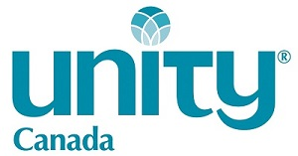

NORTHERN LIGHT GRANT

The Northern Light Grant includes tuition for courses taken in any of the three following categories:
- On campus courses at Unity Village
- On-line courses through Unity Institute
- Courses pre-approved by Unity Institute to be taken at a local, accredited institution in accordance the M&RS program policy.
Students to submit tuition invoices quarterly, along with a transcript of their successful completion of the tuition course(s) to the Treasurer of Unity Canada.
If the student is in good standing in the Unity Institute program as well as with Unity Worldwide Ministries and Unity Canada, scholarship recipients would receive a cheque for up to 25%* of the tuition amount. (*See policy below regarding caps on scholarships as a percentage of Unity Canada’s budget.)
Repayment
Upon graduation and ordination, the scholarship recipient is expected to return to Canada to minister for 2 years.
If the minister chooses not to return to Canada within 12 months following ordination and graduation, all scholarship monies are subject to repayment to Unity Canada.
In the event there is not 1) an opening in Canada or 2) no appropriate and suitable match can be made with an existing Canadian Unity Spiritual Community, the scholarship recipient can request an exception to this requirement, subject to the approval of the Board of Directors.

*Budgeted Annual Cost Policy | Proposed
That financial support for those eligible for the Northern Lights Grant will not exceed $15,000 or 10% of Unity Canada’s annual budget, whichever is less. In the event that there are more ministerial students than available funds, the scholarship funds may be prorated based on progress in the program.

