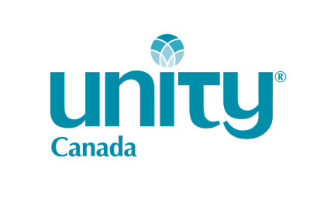

Student US Dollar Exchange Grant - Claim Form
Please Note: This grant applies to TUITION only. Minimum Claim is $25.00

Program: _______ SEE Courses _______ Ministry Path (UUMS) _______ Ministry Path (UWSI) _______ Ministry Path (Other)
Course Taken: ____On-Line ____ Unity Village ____ Church ____ Other Venue ________________________________________

Student’s Name: ____________________________________ Home Spiritual Centre: ______________________________________
Student’s Address: _________________________________________________________________________________________
City: ________________________________________ Province: ________________________ P.C. ________________________
Phone #: ______________________ Email: _________________________ E-transfer _____ yes _____no

Courses Taken:
COURSE TITLE | DATE COMPLETED | CAN $ COST | US $ COST | DIFFERENCE
TOTALS
If you need more room, please attach a separate sheet.
Required Documents Attached: _____ Receipt of payment in Canadian $; ______US$ charge; _____ Transcript of completed course
Date: ____________________ Signature ________________________________________

Mail Form and supporting documents to: Unity Canada, PO Box 5158 Stn Baden, Baden, ON N3A 4J3
OR Email Form & supporting documents to: accounting@unitycanada.org Attn. UC Treasurer

